**Appium Grid**

Youtube URL: <https://www.youtube.com/watch?v=U1hkVFxHnR4&list=PLXbcghgSZDrq7rUFsXoR-7idS4DFTOqKO&index=1>

GitHub:

<https://github.com/freeautomationlearning/AppiumGrid>

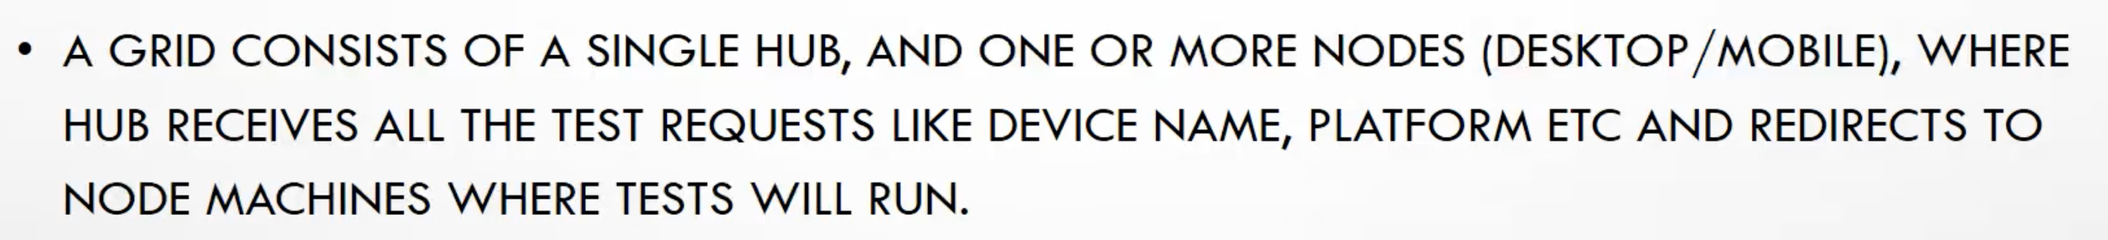

For parallel testing and cross device testing.

**Step-1 :**

First configure the HUB and the configure the hub with two different computers. Each of the PCs are connected with multiple android real devices which we consider as nodes. See image below:

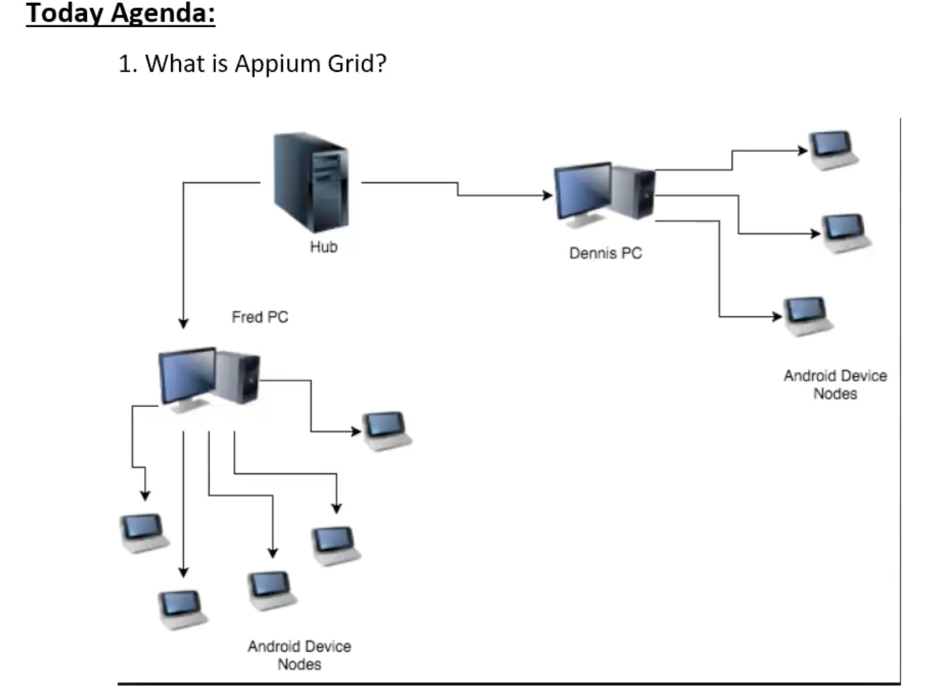

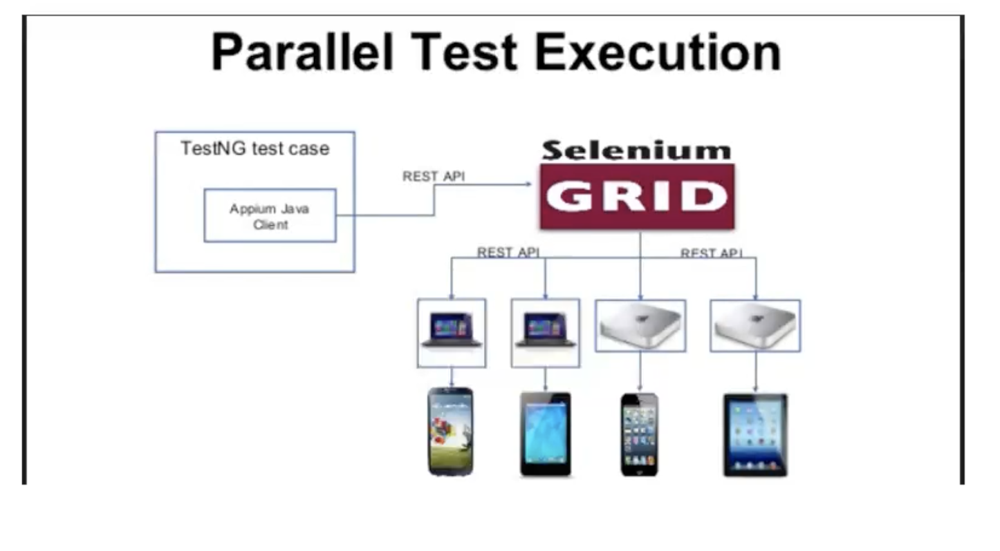

**Step-2 :**

Set up the appium grid. You can run appium session either writing commands in the command line or creating bat/**batch** file in windows. Selenium stand alone jar file to strat the hub. For each nodes you have to run your server instance with different port. Also set the log file path in a different area. Start the server before you run your test.

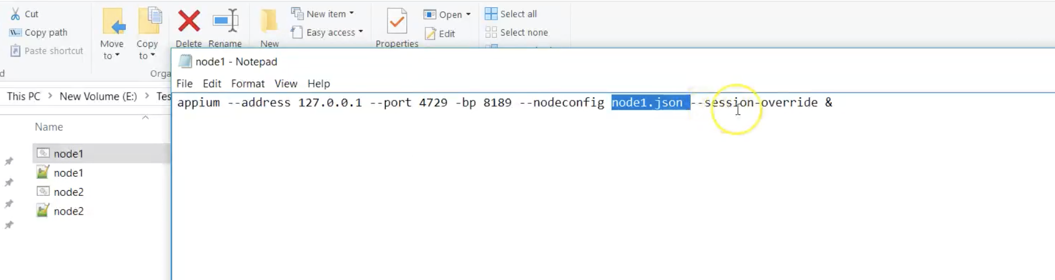

you have to create your config.jason file which you gonna call in your session. See below:

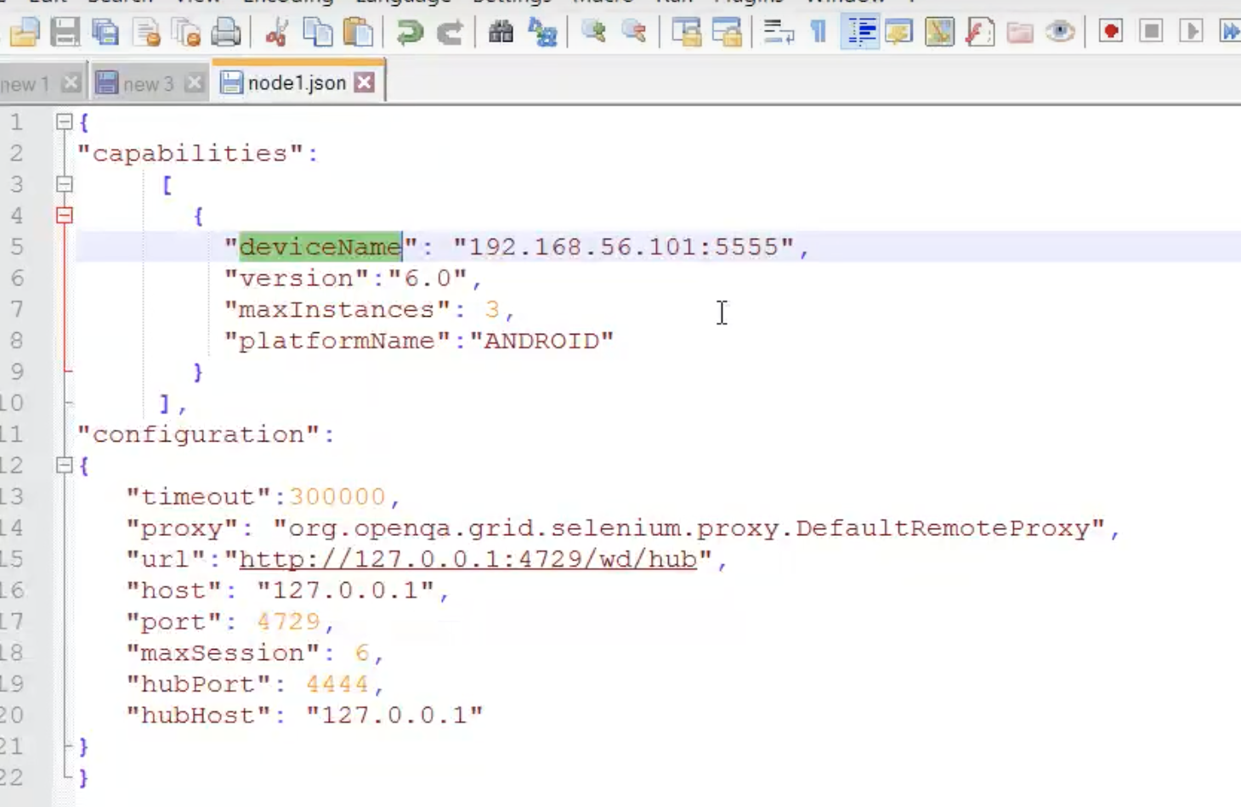

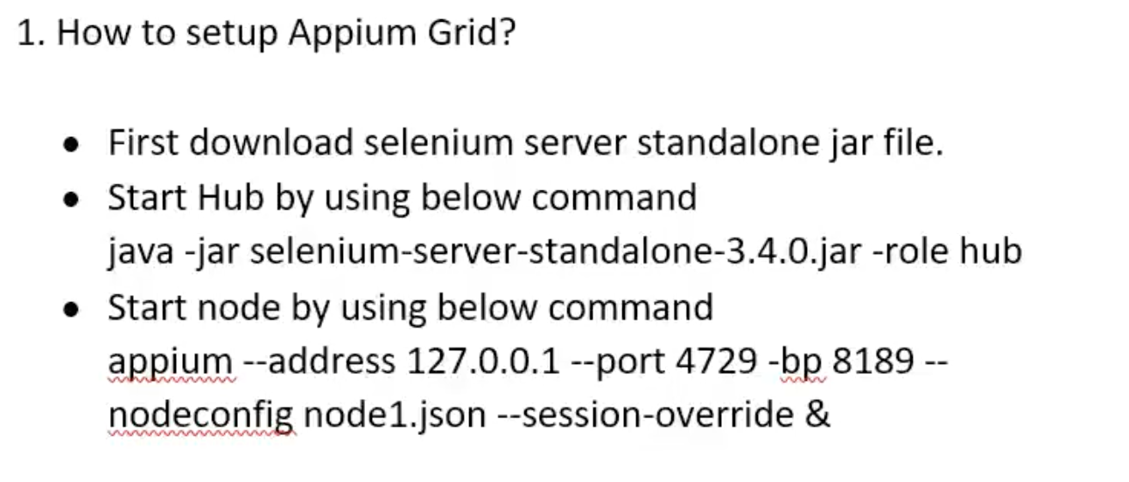

**Step-3 :**

We will run our test from testng.xml file where we set up the configuration for each of the parallel testing and then will run our test suite. We use parameter to config our test and take the parameter in our base class.

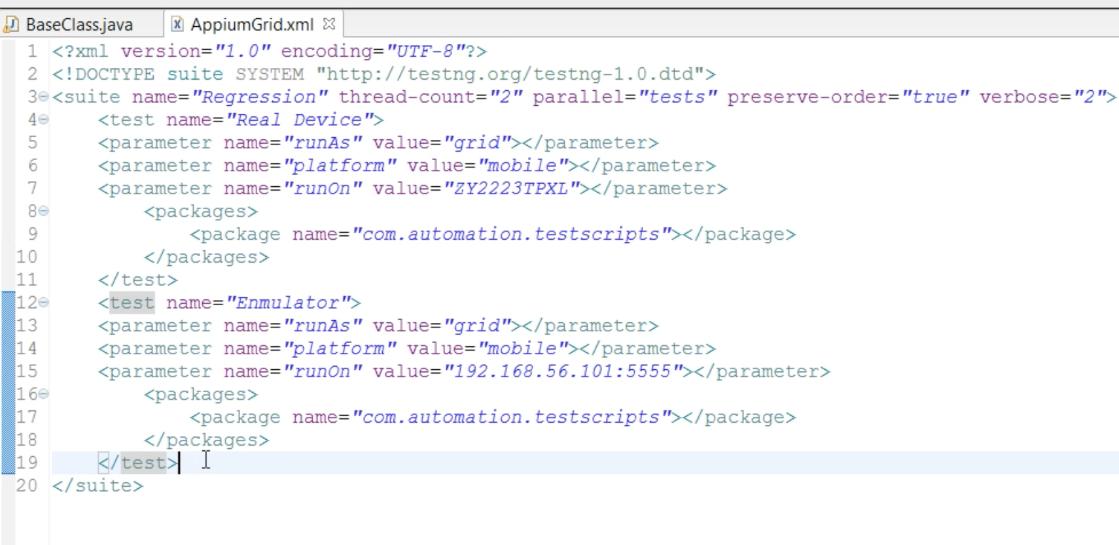

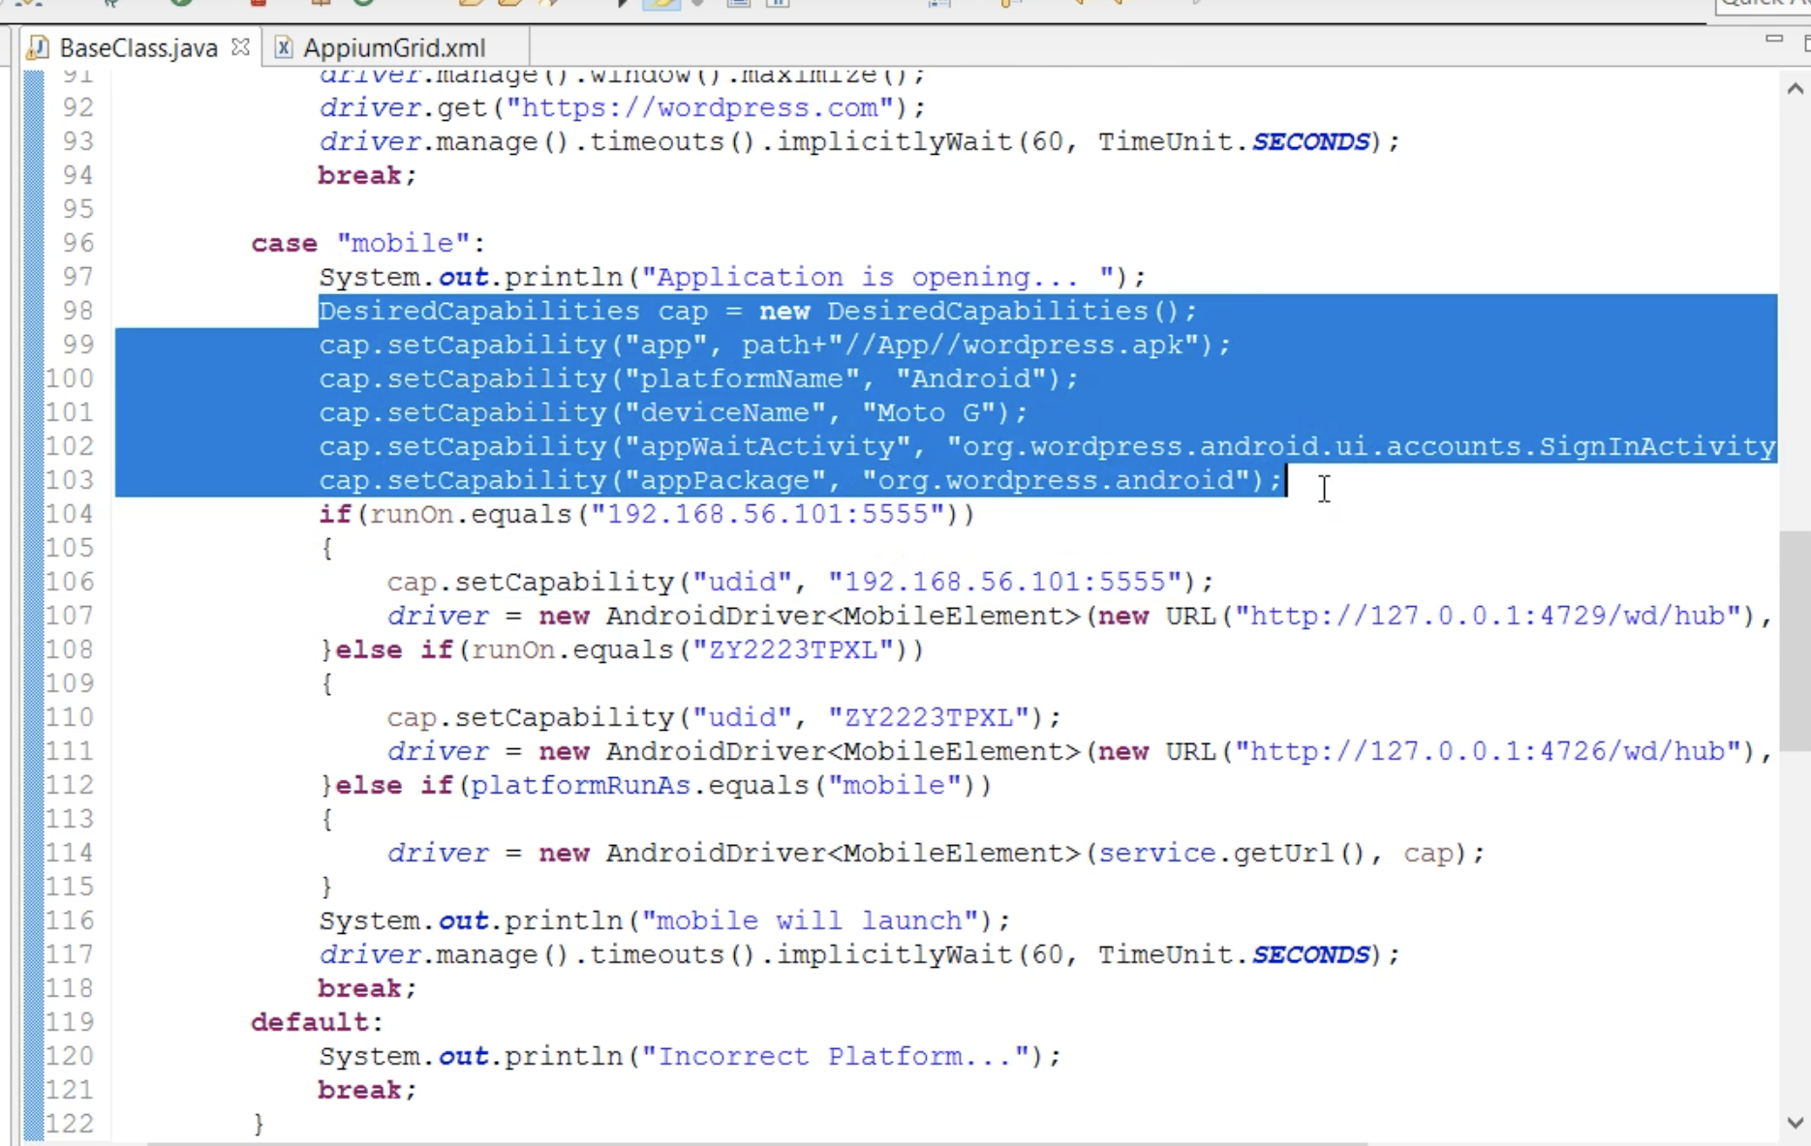

instead of creating json file you create your xml file with all the config

